CONDITION_OCCURRENCE:

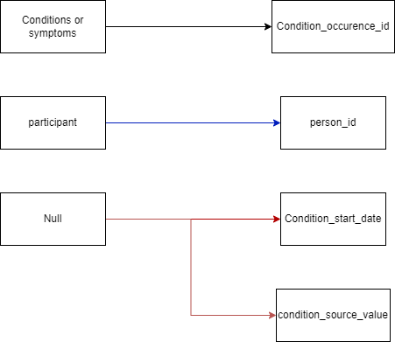

| Destination field | Source field | Logic | Comment |
| --- | --- | --- | --- |
| Condition_occurence_id | int | dit is een int, van 1 t/m 3 |  |
| Person_id | int | Participant is al een unieke numerieke waarde |  |
| Condition_start_date | Null |  |  |
| Condition_source_value | Null |  |  |